

**GHARDA INSTITUTE OF TECHNOLOGY**

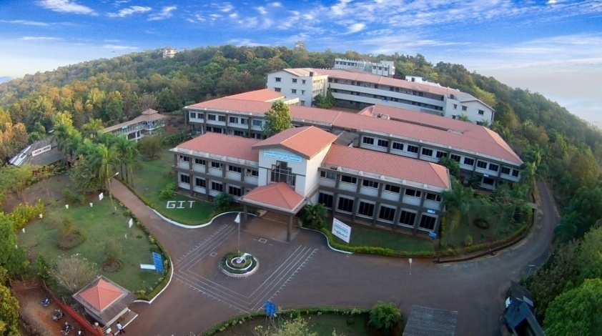

**NAAC**

**Criteria VII**

**7.1.3 Describe the facilities in the Institution for the management of the following types of degradable and non-degradable waste**

**View Slideshow :** [**http://www.git-india.edu.in/git/naac/7.1.3/photogallery.asp**](http://www.git-india.edu.in/git/naac/7.1.3/photogallery.asp)

**1. BioFilter Plant**

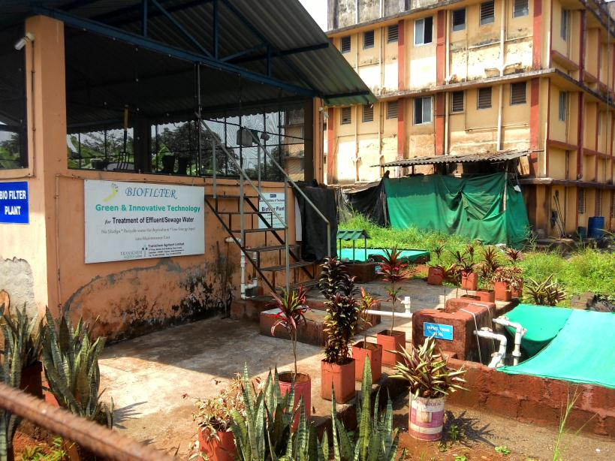

**2. Organic Waste Converter**

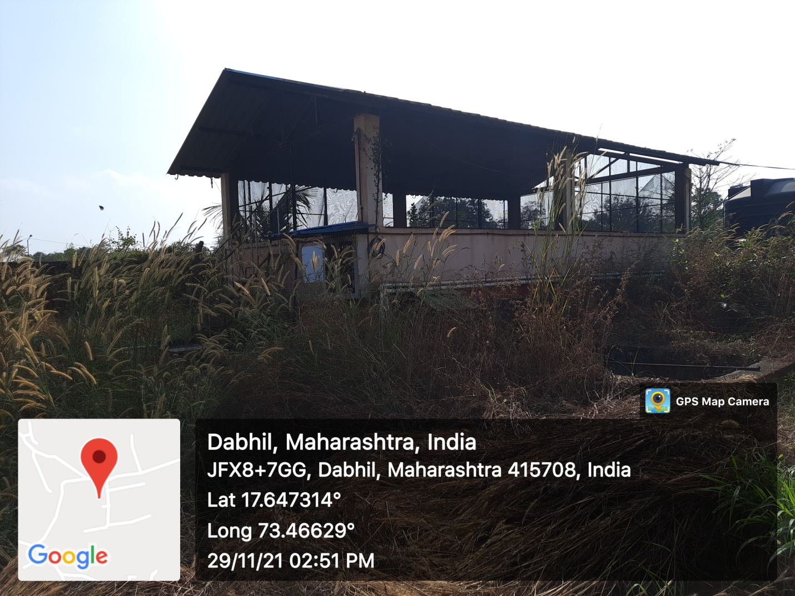

**3. Water Treatment**

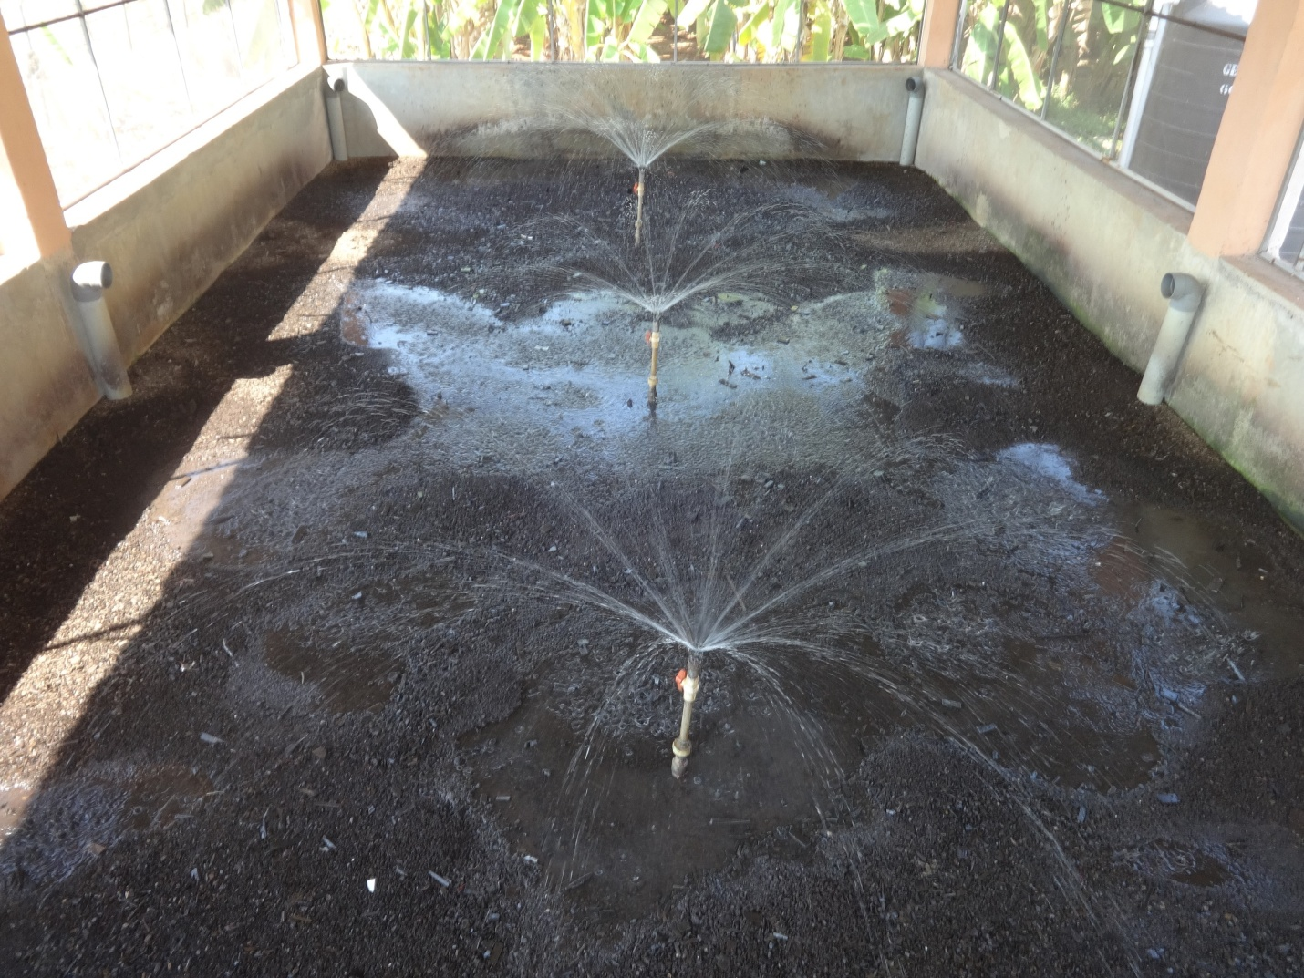

**4. Solid Waste Management**

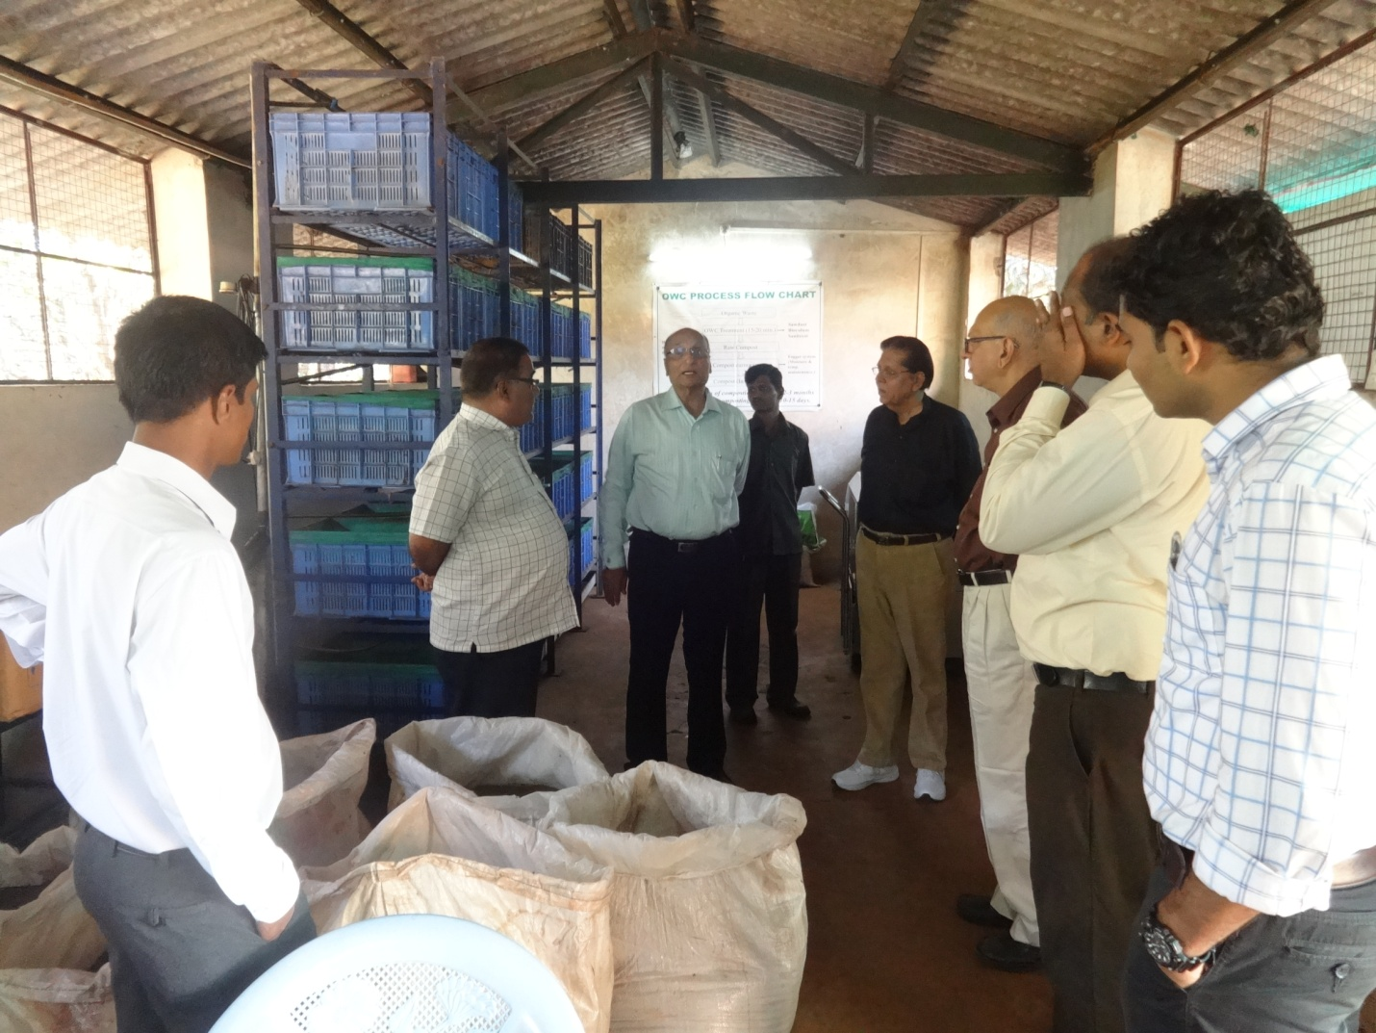

**5. Borewell**

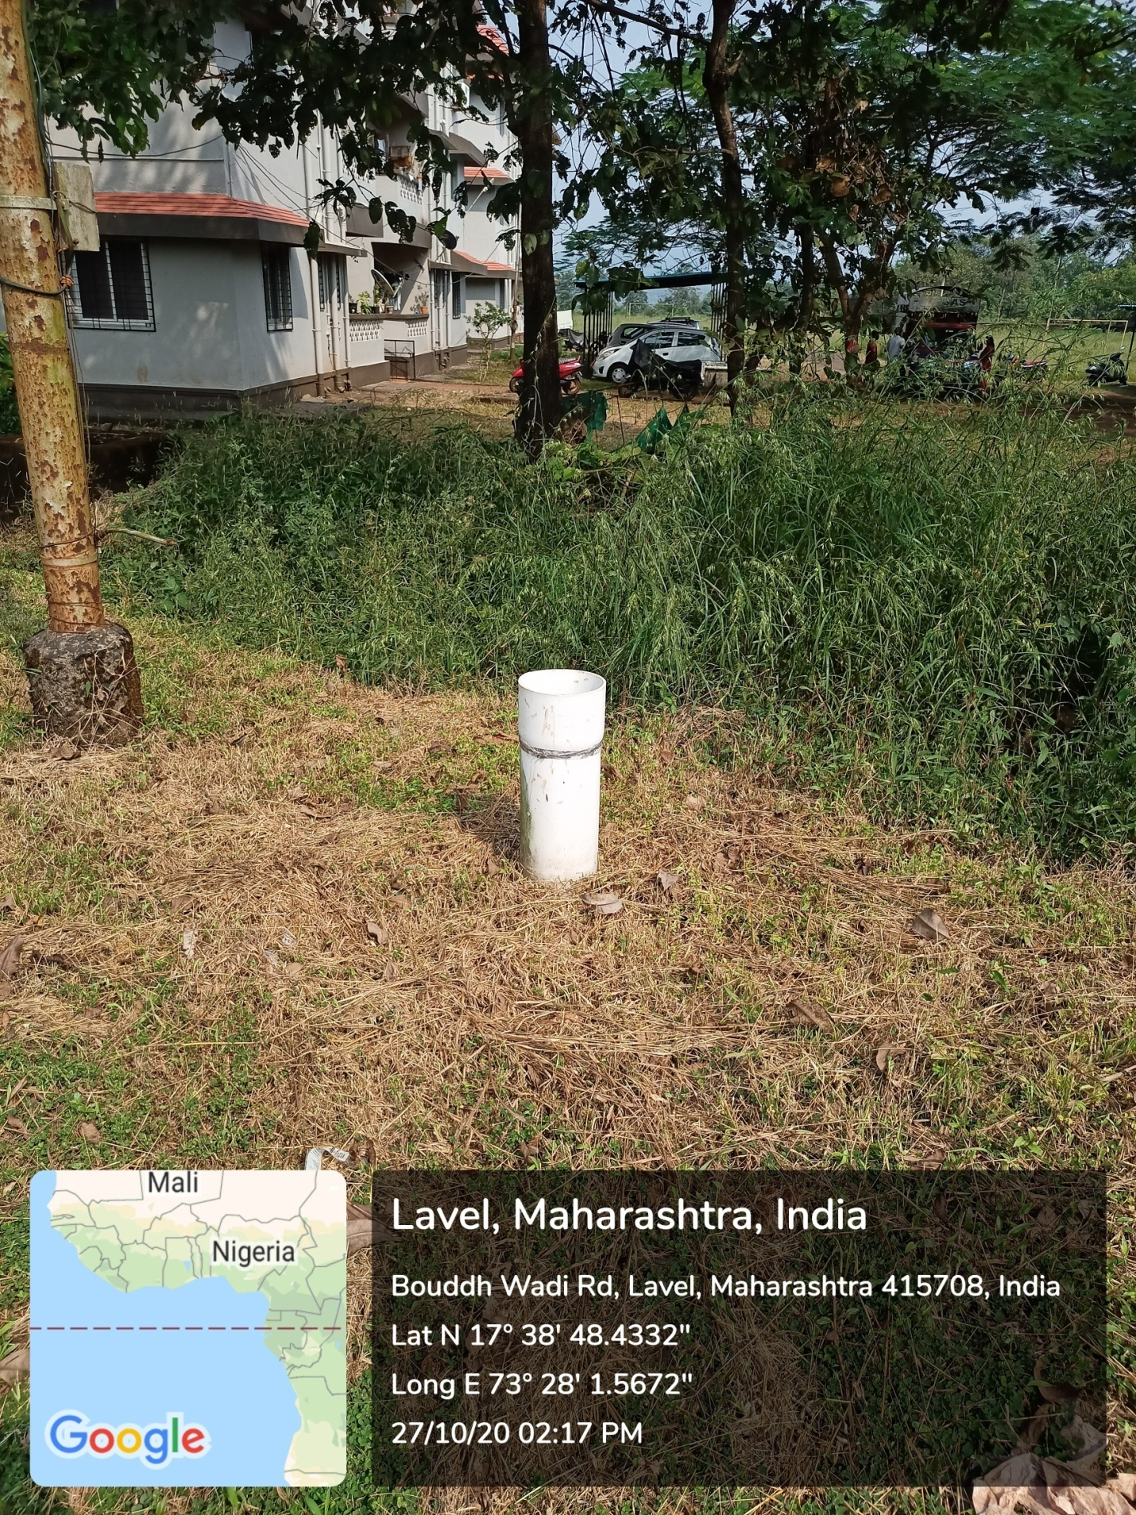

**6. Chemical Waste Collection**

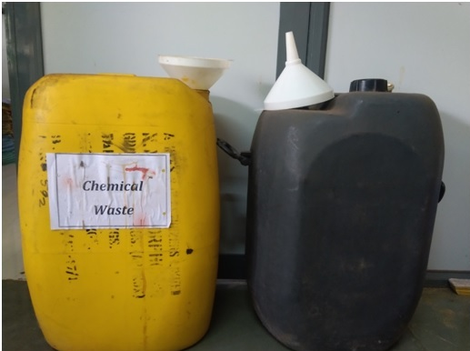

**7. BRGH Hospital**

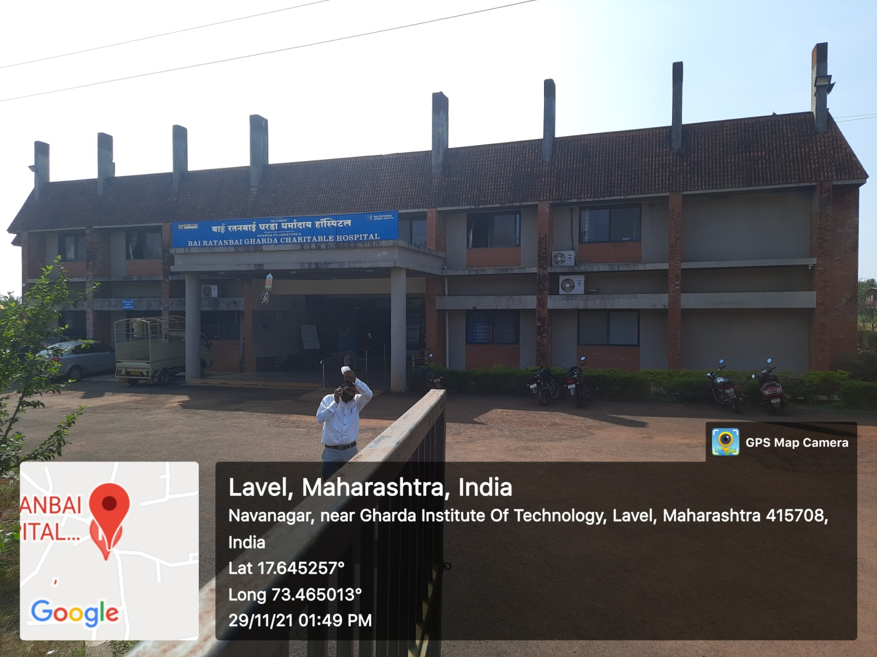

**8. Saftey in Chemical Lab**

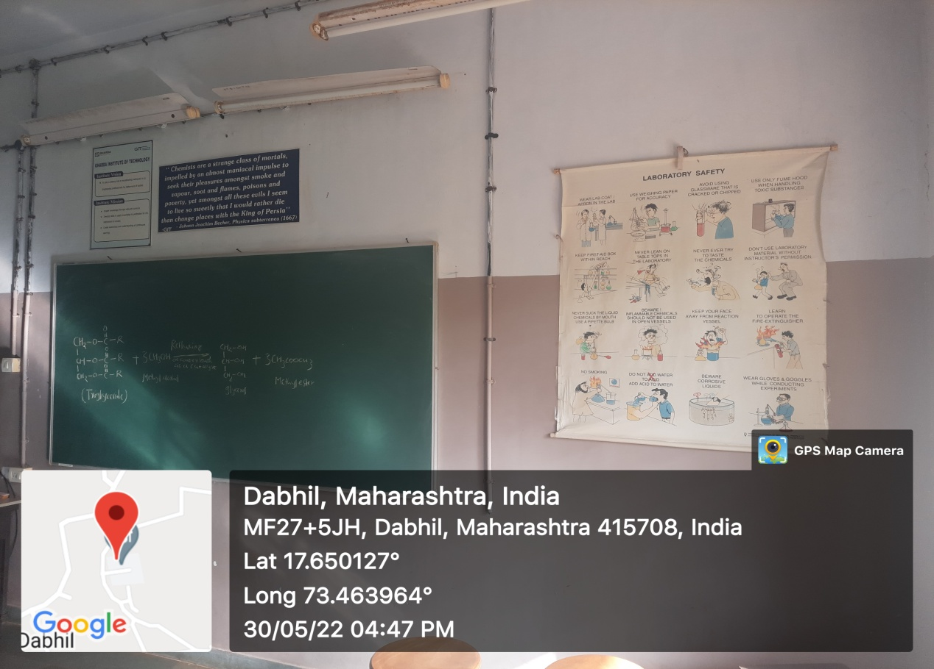

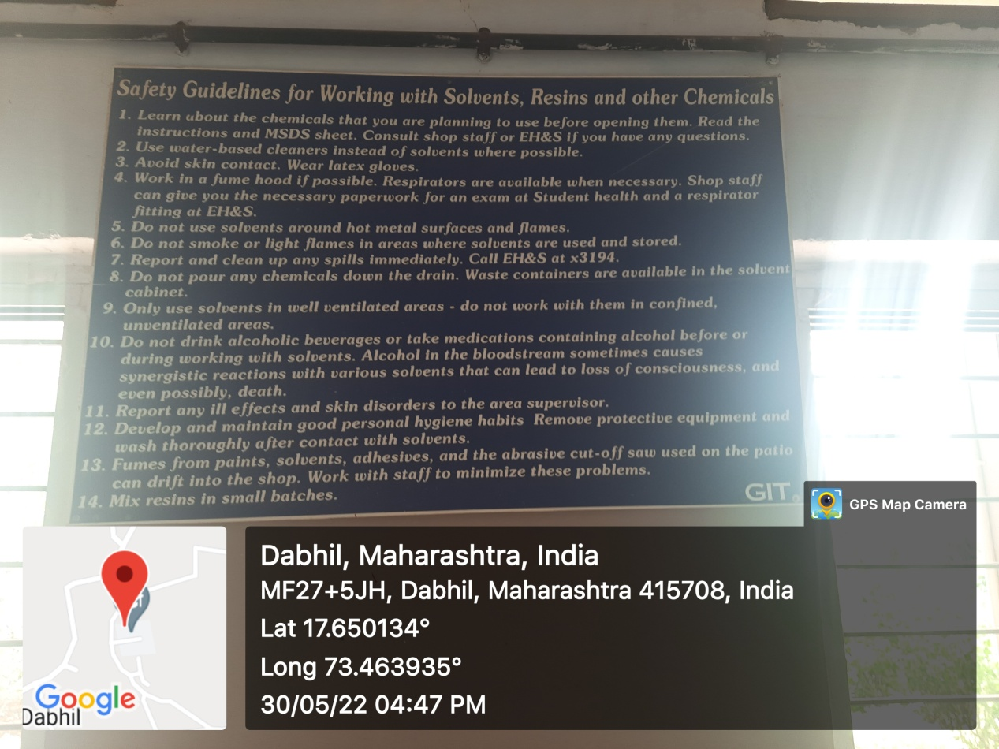

**Eye Washer & Shower**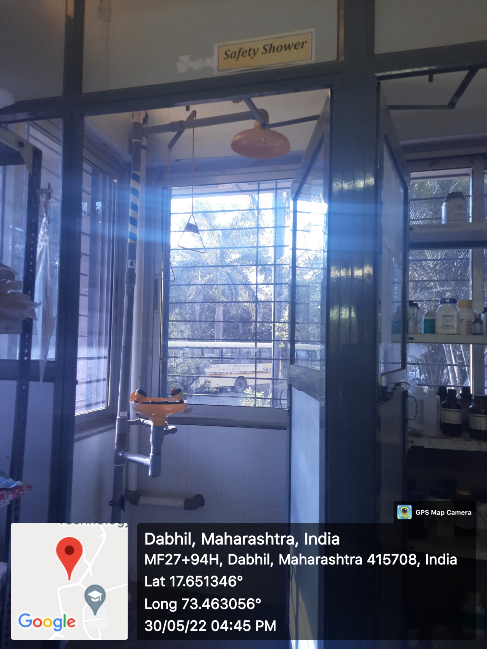

**Hand Gloves & Goggles**

